بسمه تعالی
چکیده سخنرانی ژورنال کلاب دانشجویان دکترا ورودی 98
دانشکده بهداشت – گروه مهندسی بهداشت محیط
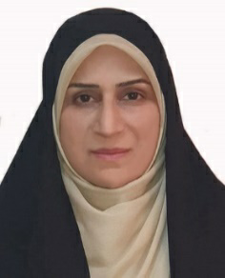
نام و نام خانوادگی دانشجو : راضیه شیخی
شماره دانشجویی: 9811150005
استاد راهنمای آموزشی: جناب آقای دکتر محمدهادی دهقانی
تاریخ :9/3/1400 ساعت:15
عنوان مقاله :
Treatment of Organics Contaminated Wastewater by Ozone Micro-Nano-Bubbles
چکیده:

The efficiency of ozone for the treatment of organics contaminated wastewater is limited by its slow dissolution rate and rapid decomposition in the aqueous phase. Micro-nano-bubbles (MNBs) are a novel method to prolong the reactivity of the ozone in the aqueous phase, thereby accelerating the treatment of the contaminant. In this study, the effects of pH and salinity on the treatment efficiency of ozone MNBs were examined. The highest efficiency was observed in weak acidic conditions and an increase in salinity enhanced the treatment efficiency significantly. Furthermore, the treatment of highly saline industrial wastewater as well as multi-contaminant groundwater containing persistent organics were also investigated. Treatment using ozone MNBs had a considerable effect on wastewaters that are otherwise difficult to treat using other methods; hence, it is a promising technology for wastewater treatment.

